## **Objectives**

* Explain React events
* Explain about event handlers
* Define Synthetic event
* Identify React event naming convention

In this hands-on lab, you will learn how to:

* Implement Event handling concept in React applications
* Use this keyword
* Use synthetic event

## **Prerequisites**

The following is required to complete this hands-on lab:

* Node.js
* NPM
* Visual Studio Code

**src/components/CurrencyConvertor.js:**

import React, { useState } from "react";

export default function CurrencyConvertor() {

const [inr, setInr] = useState("");

const [euro, setEuro] = useState("");

const handleSubmit = (e) => {

e.preventDefault();

const inrValue = parseFloat(inr);

if (!isNaN(inrValue)) {

const euroValue = inrValue / 90; // example rate: 1 EUR = 90 INR

setEuro(euroValue.toFixed(2));

}

};

return (

<div style={{ marginTop: 20 }}>

<h3>Currency Converter (INR → EUR)</h3>

<form onSubmit={handleSubmit}>

<input

type="number"

placeholder="Enter amount in INR"

value={inr}

onChange={(e) => setInr(e.target.value)}

/>

<button type="submit">Convert</button>

</form>

{euro && <p>{inr} INR = {euro} EUR</p>}

</div>

);

}

**src/App.js:**

import React, { useState } from "react";

import CurrencyConvertor from "./components/CurrencyConvertor";

export default function App() {

const [count, setCount] = useState(0);

// Method 1: Increment counter

const increment = () => setCount(count + 1);

// Method 2: Decrement counter

const decrement = () => setCount(count - 1);

// Extra method to show hello

const sayHello = () => console.log("Hello! This is a static message.");

// Method with parameter

const sayMessage = (msg) => alert(msg);

// Synthetic event example

const handlePress = (e) => {

e.preventDefault();

alert("I was clicked");

};

return (

<div style={{ padding: 20, fontFamily: "Arial" }}>

<h1>React Event Handling Examples</h1>

{/* Increment and Decrement */}

<p>Counter: {count}</p>

<button onClick={() => { increment(); sayHello(); }}>Increment</button>

<button onClick={decrement}>Decrement</button>

{/* Button with parameter */}

<div style={{ marginTop: 10 }}>

<button onClick={() => sayMessage("Welcome")}>Say Welcome</button>

</div>

{/* Synthetic event */}

<div style={{ marginTop: 10 }}>

<button onClick={handlePress}>OnPress Example</button>

</div>

{/* Currency Converter */}

<CurrencyConvertor />

</div>

);

}

## **Notes**

Estimated time to complete this lab: **90 minutes.**

Create a React Application “eventexamplesapp” to handle various events of the form elements in HTML.

1. Create “Increment” button to increase the value of the counter and “Decrement” button to decrease the value of the counter. The “Increase” button should invoke multiple methods.
   1. To increment the value
   2. Say Hello followed by a static message.

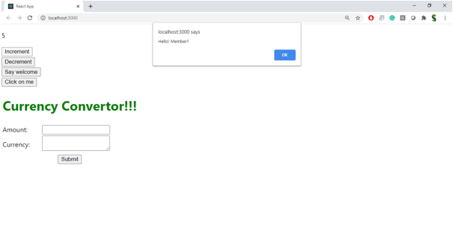

1. Create a button “Say Welcome” which invokes the function which takes “welcome” as an argument.

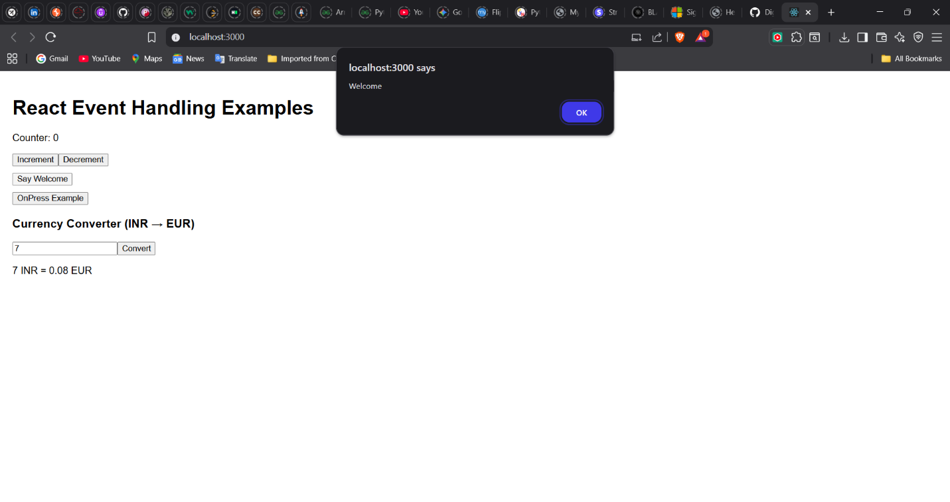

1. Create a button which invokes synthetic event “OnPress” which display “I was clicked”

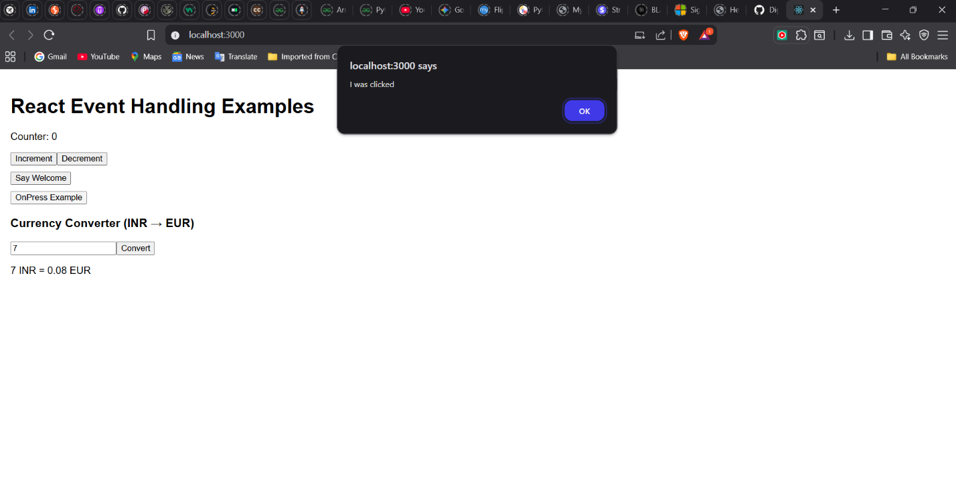

Create a “CurrencyConvertor” component which will convert the Indian Rupees to Euro when the Convert button is clicked.

Handle the Click event of the button to invoke the handleSubmit event and handle the conversion of the euro to rupees.

